Pavilion at Ravenwood Hall Hotel, Rougham, stages wedding open day after refurbishment
14:06 Monday 24 April 2017

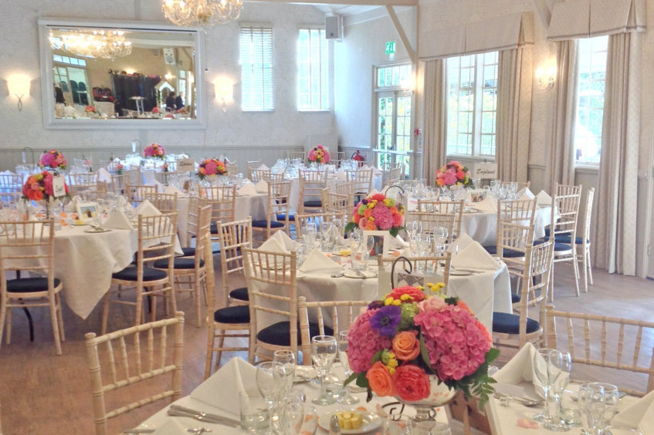
The newly furbished Pavilion at Ravenwood Hall Rougham ready to provide perfect wedding venue
The Pavilion at Ravenwood Hall, Rougham, stages a wedding open day on April 30 and will reveal its stunning refurbishment.
Craig Jarvis, owner of the Hall which dates back to Tudor times, has employed the talents of interior designer Jane Capleman to create a light and elegant room that works with all colour schemes.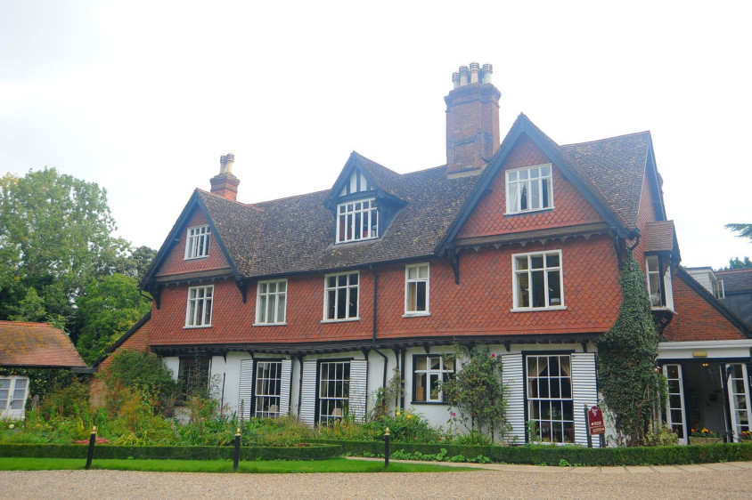
Ravenwood Hall Hotel
The Edwardian cricket pavilion was rescued by Craig from his old school Nowton Court when it closed in 1990. Since then it has been the venue for hundreds of events and celebrations.
The redesign uses light and natural materials with a limed oak finish hard floor and Woodland Toile wallpaper by Sanderson. Bedspoke hand made curtains dress the windows and mirrors and romantic lighting create a spacious wedding venue.
Jane said: “We wanted to create a gentle backdrop that will work with all colour schemes. The light neutral tones allow couples to add the splashes of colour they want for their wedding.”
Craig said: “We’re absolutely thrilled with the results. Jane and all the craftsmen involved in the refurbishment have created a venue that we know future wedding parties will love.”
The Pavilion is suitable for 100 guest civil ceremonies and 130 seated wedding breakfasts.
Entry to the Open Day is free. It runs from 11am to 4pm.

